Assignment 1

Due March 1st 11:55pm

In this assignment you will configure the Midwest Realty website to display on mobile devices using the single-column layout shown below. You will create a new mobile style sheet (midwestmobile.css), modify the current styles, and configure the index page with media queries and viewport meta tag. When you are finished, the website will look the same (Figure 1) in desktop browsers. The mobile display should be similar to Figure 2.

You will find files (index.html, midwest.css and midwest.gif) for the assignment under Course Documents on the Blackboard.

**Submit your completed work to Blackboard after testing with different emulators. You may want to zip the multiple files.**

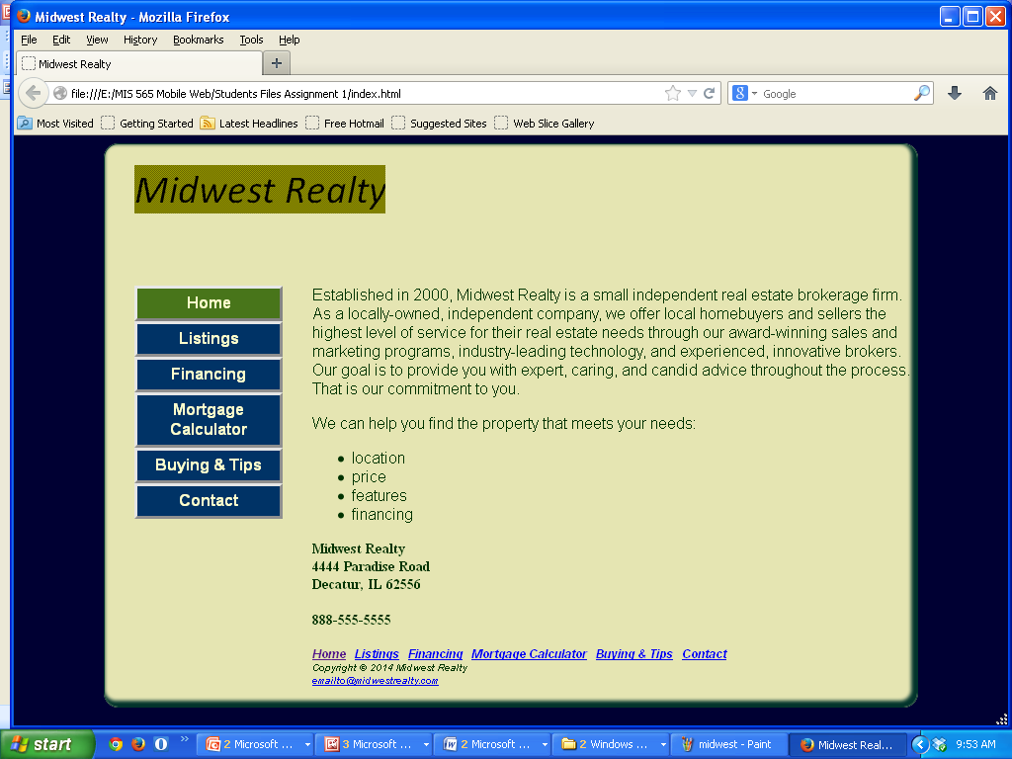

Figure 1 - Website on desktop browser

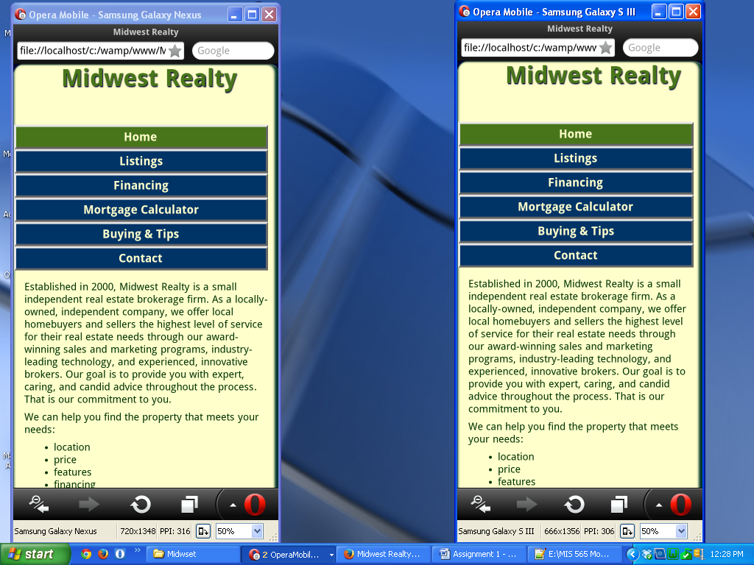

Figure 2 – The new mobile home page displayed on Opera Emulator